Name : Saurabh Sanjay Jadhav

Topic : Dockerfile-1

Assignment no. : 9

1. Install docker.

curl -fsSL https://get.docker.com -o install-docker.sh

sudo sh install-docker.sh

1. Create dockerfile.
2. CMD : Specify initial command when container will start.

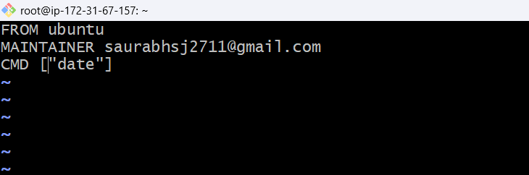

Build the dockerfile

Docker build -t <image-name> <path-to-dockerfile>

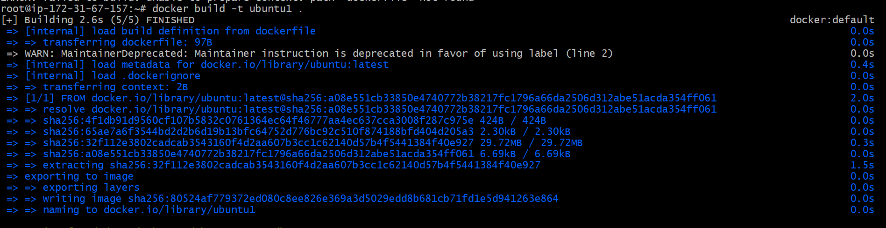

Check the image created using dockerfile.

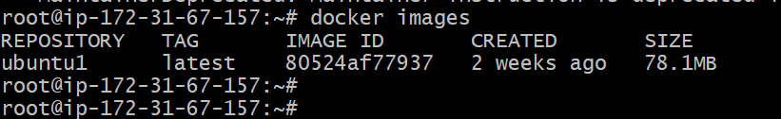

Run the container, we will get the date after the container starts.

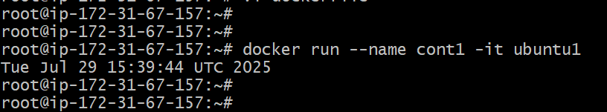

Added CMD [“ls”]

Container will show file while container starts.

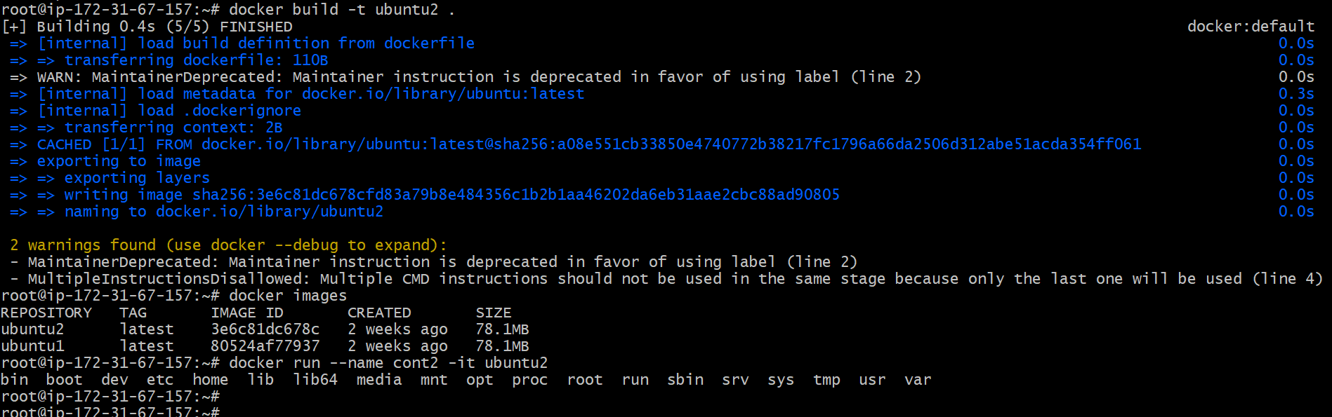

1. RUN apt-get update

RUN apt-get git -y

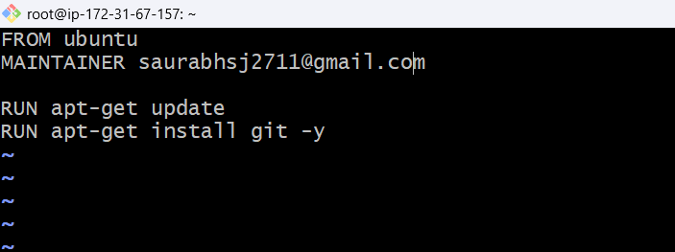

Run the container and check the git version

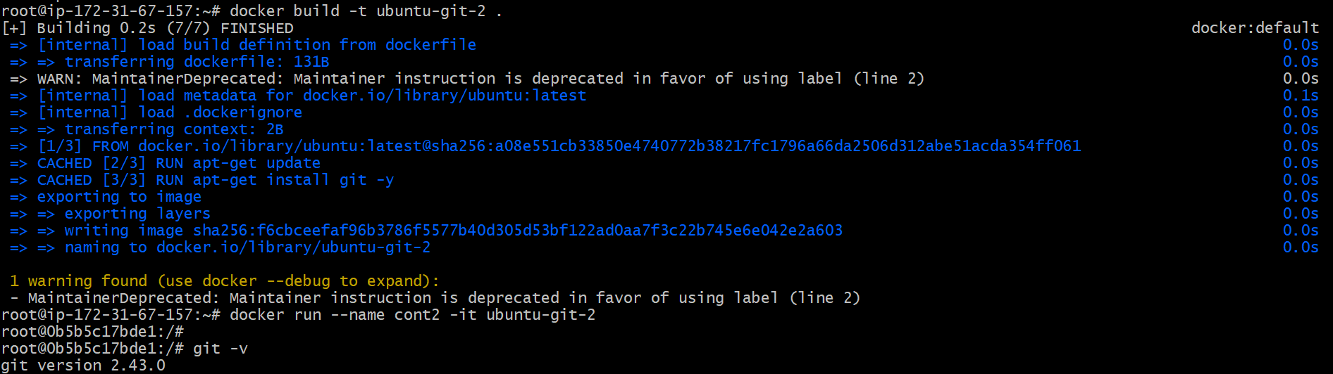

1. COPY file1.txt /

Copy file from host instance to docker container.

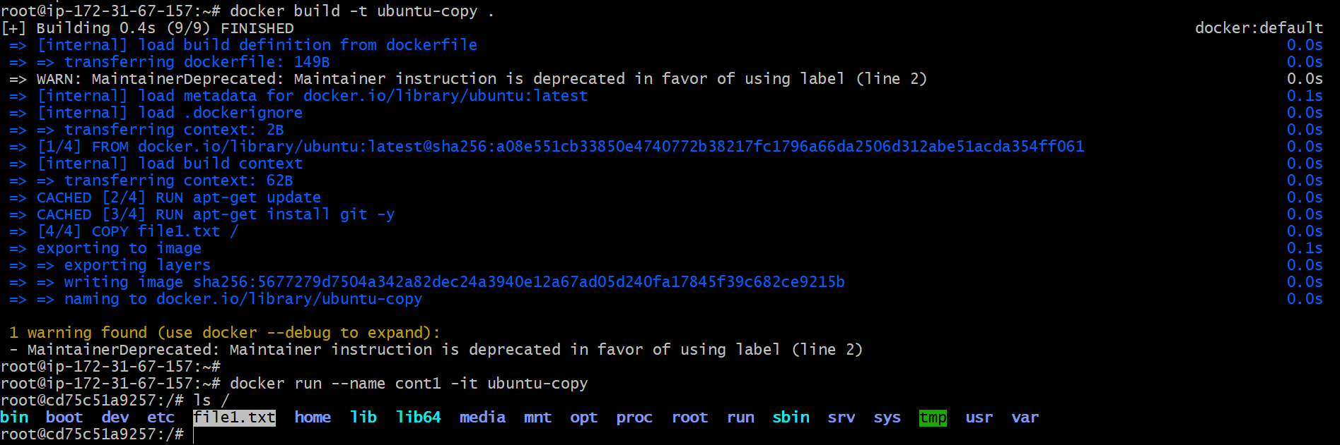

1. ADD <host file> <path in image>

ADD file2.txt /

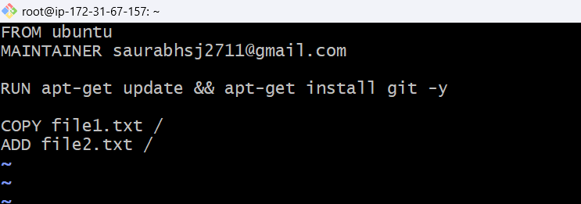

Successfully added the file to container.

